**STOCK MARKET CHART**

**NAME : NAVEDHA V**

**EMPLOYEE ID : 760850**

**(MIDDLEWARE BATCH 2)**

**SCREENSHOTS**

1. HOMEPAGE



1. **USER LOGIN PAGE**

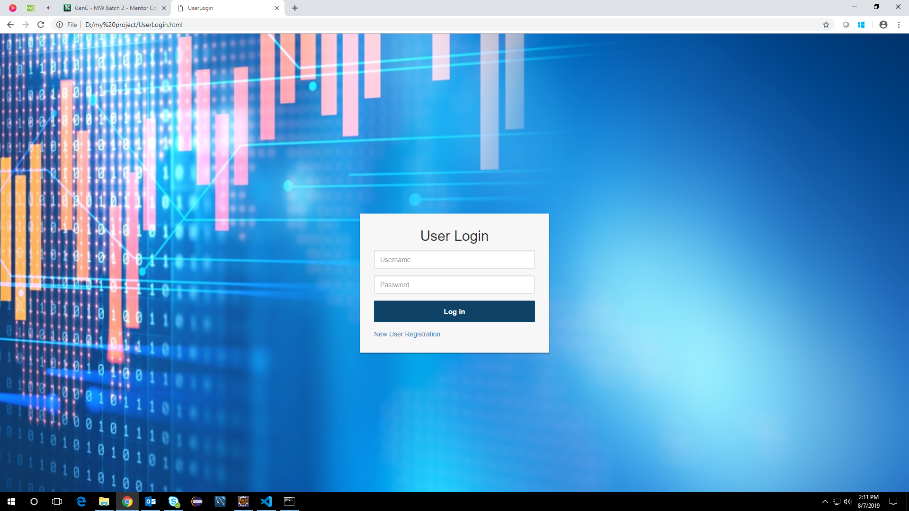

**3.USER LANDING PAGE**

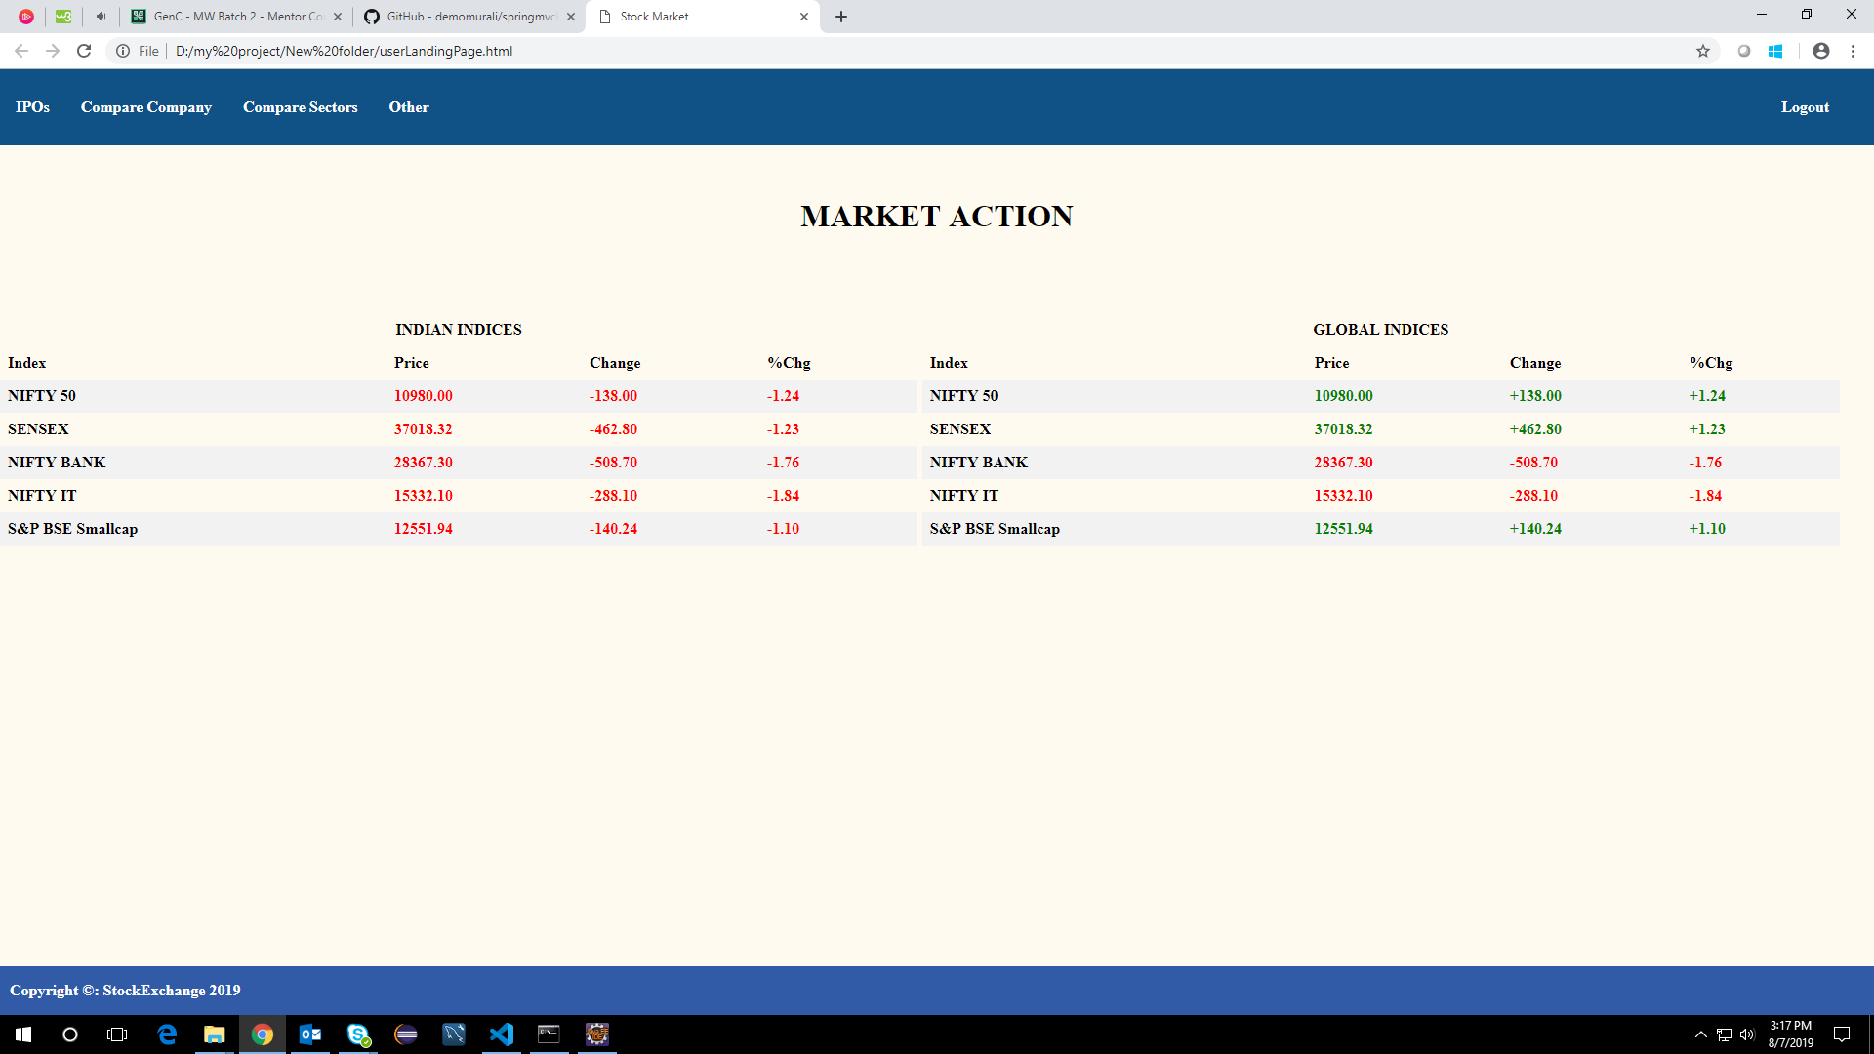

**4.USER VIEWS IPO DETAILS**

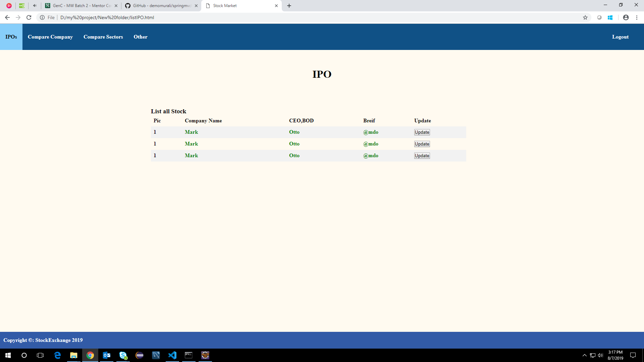

**5. COMPARE COMPANY**

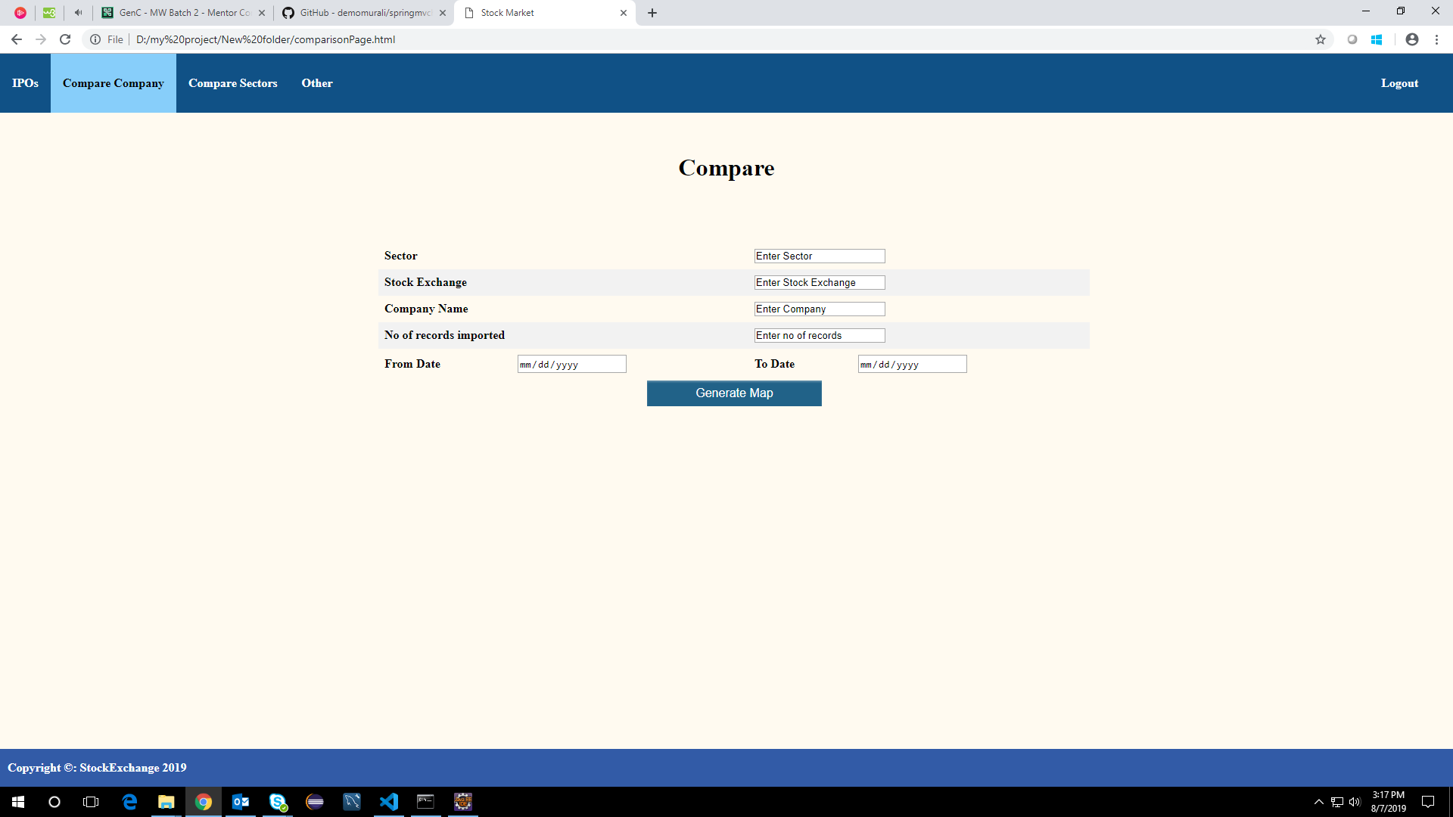

**6. ADMIN LOGIN PAGE**

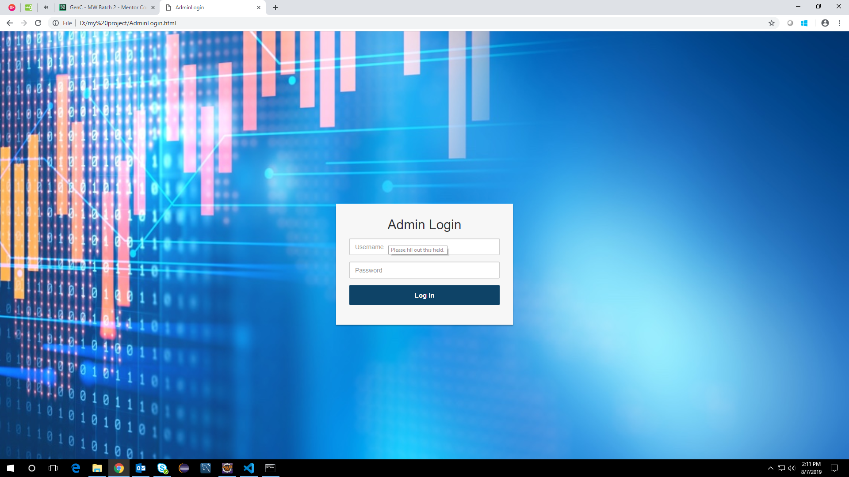

**7. ADMIN LANDING PAGE**

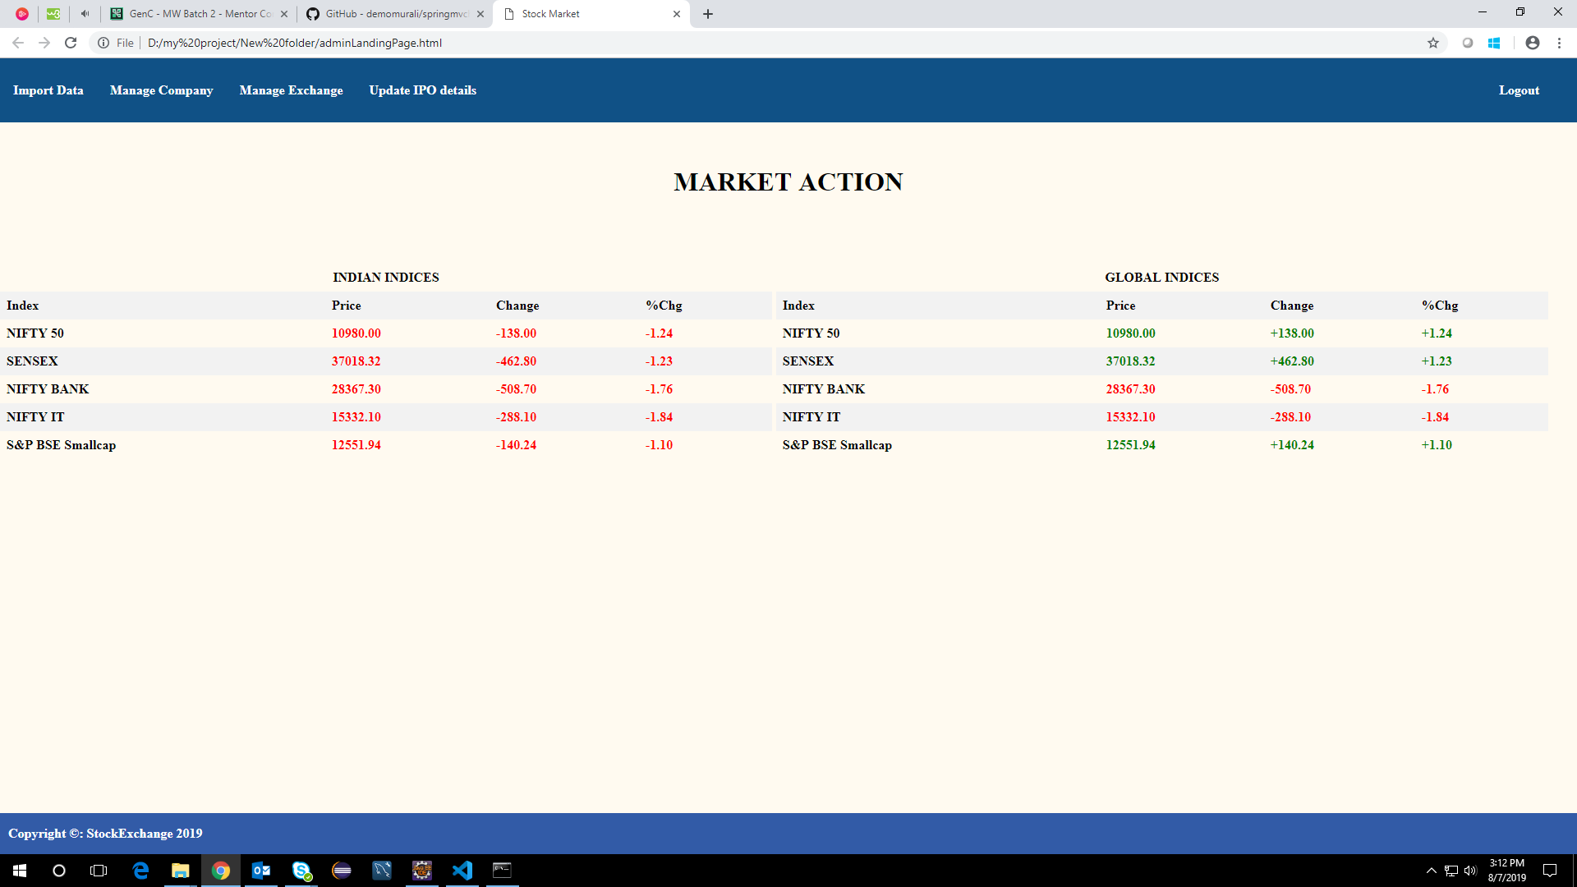

**8. IMPORT DATA**

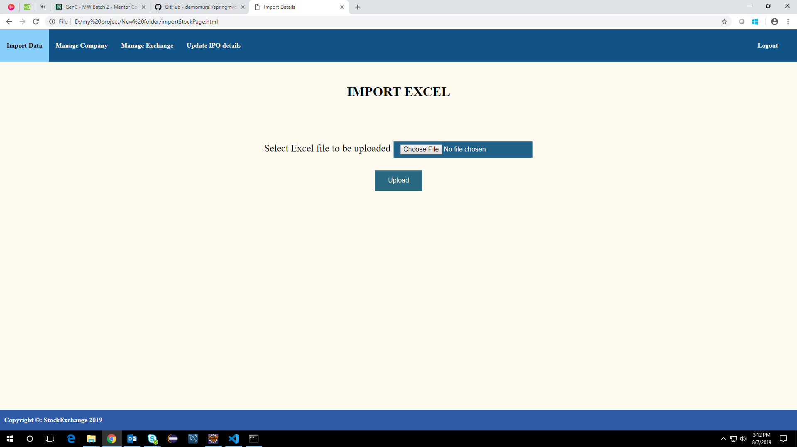

**9. SUMMARY OF UPLOAD**

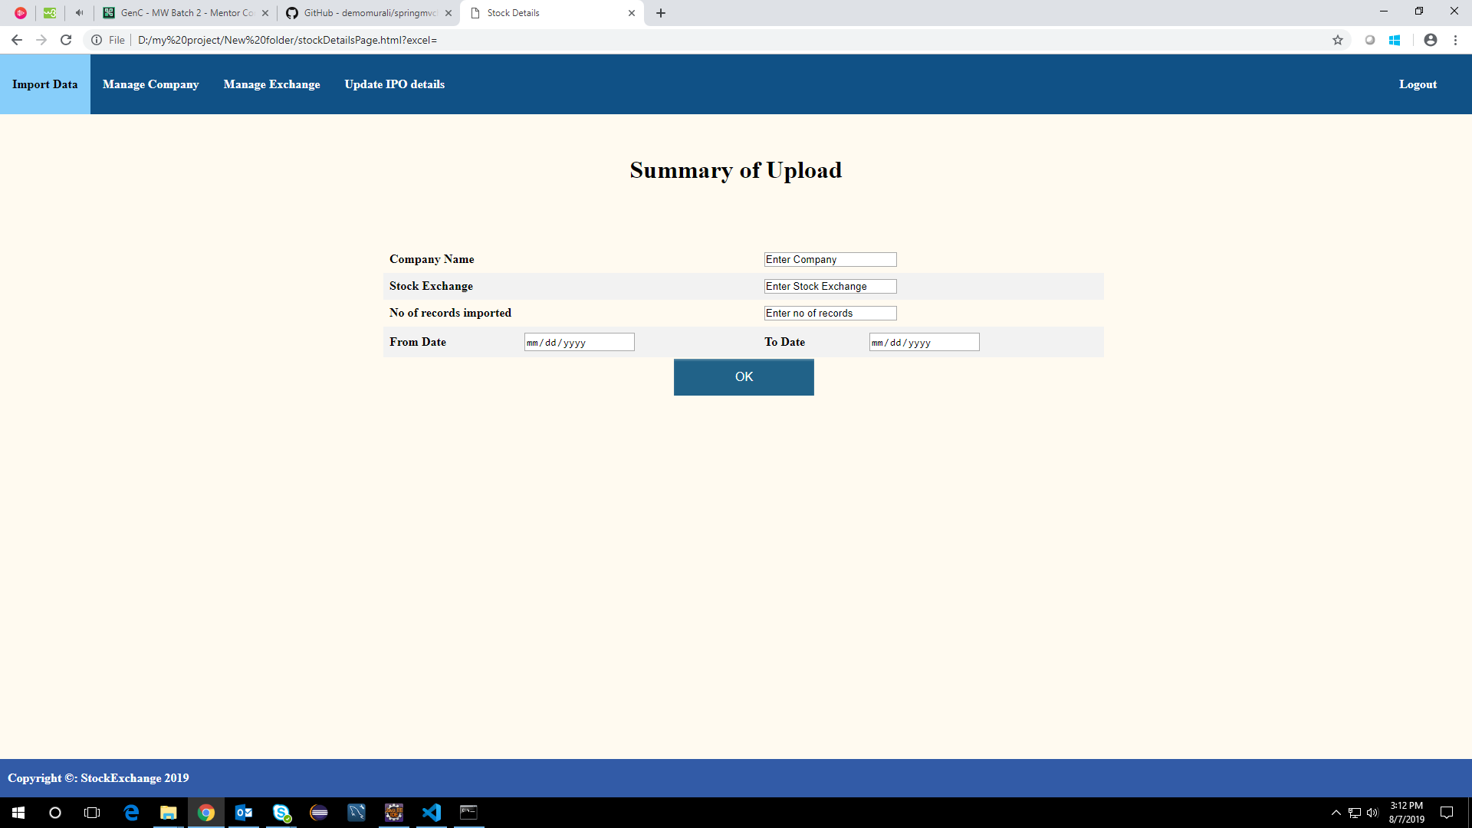

**10. LIST OF COMPANIES**

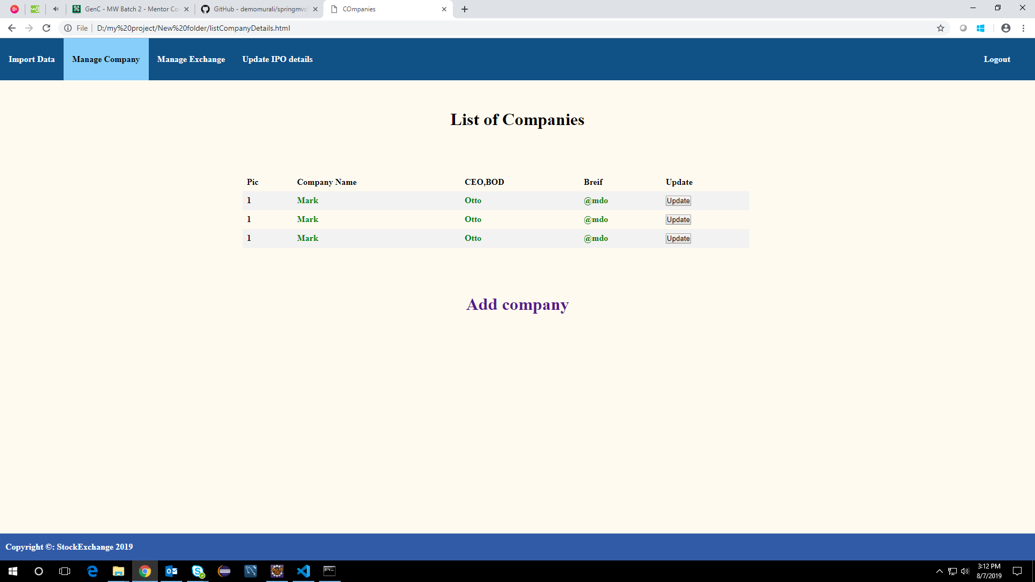

**11. CREATE NEW COMPANY**

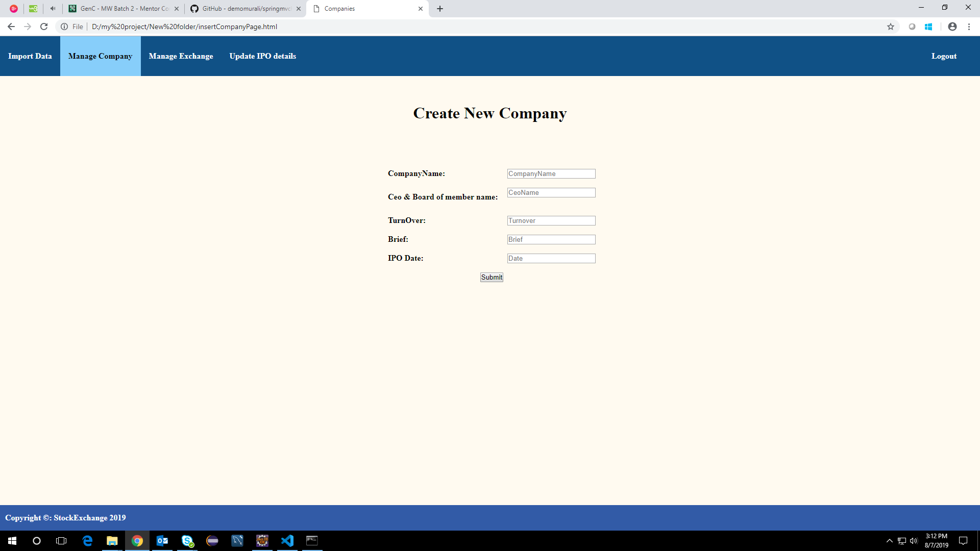

**12. LIST OF STOCK EXCHANGE**

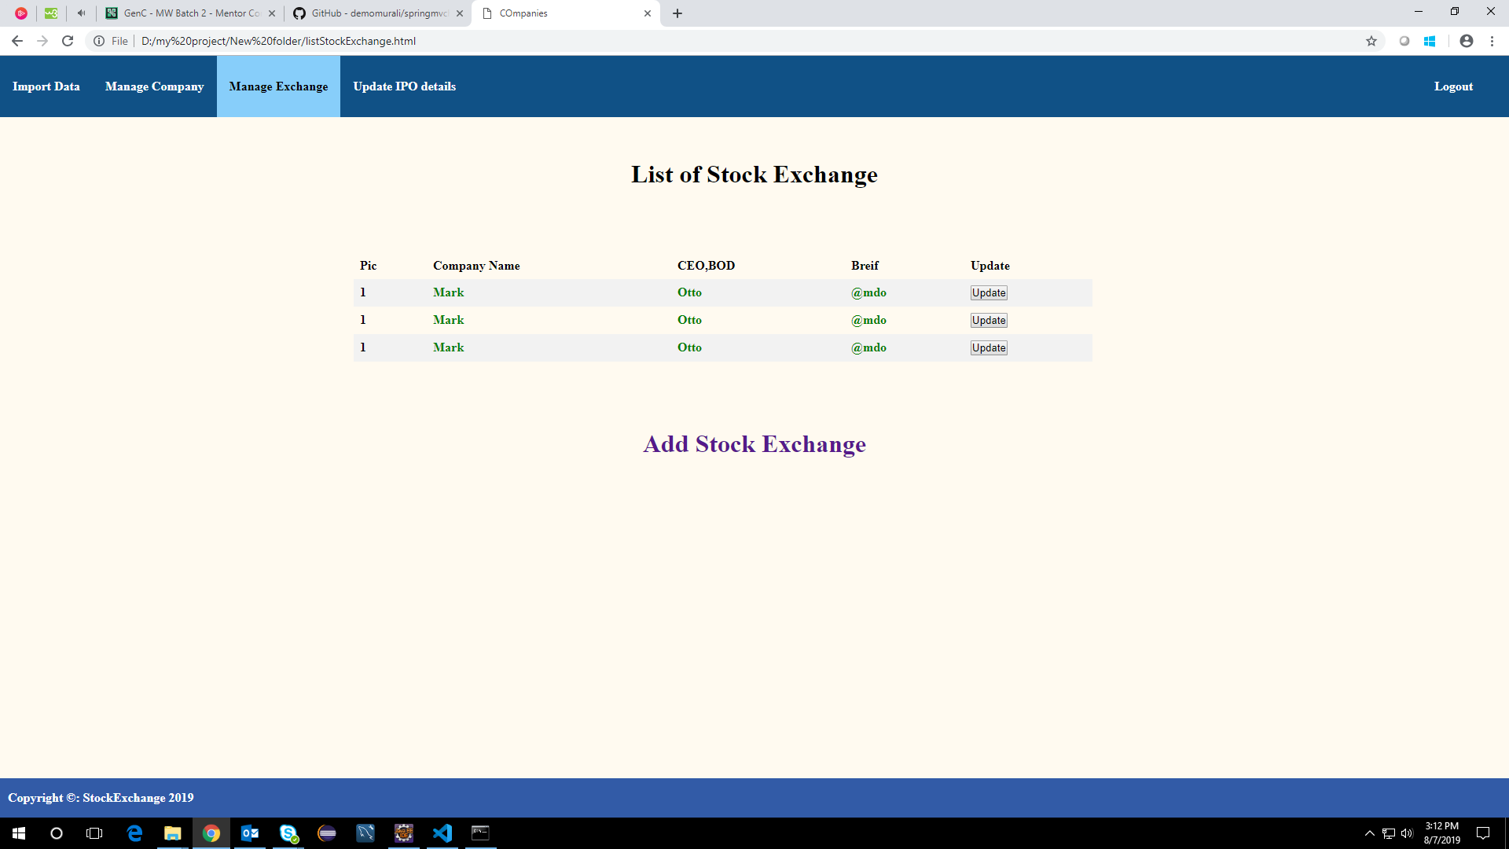

**13. CREATE NEW STOCK EXCHANGE**

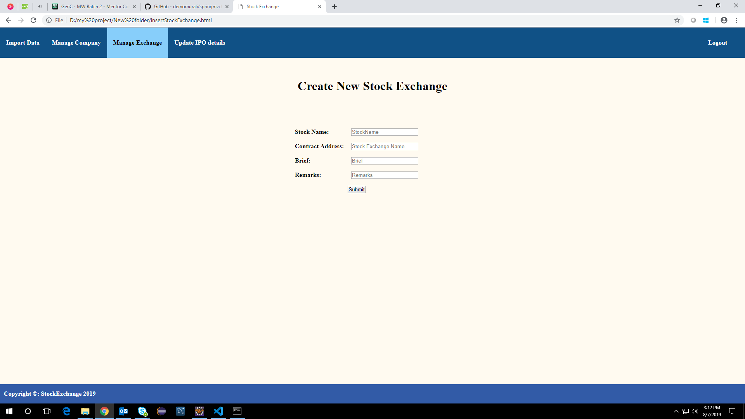

**14. ADD IPO PLAN**

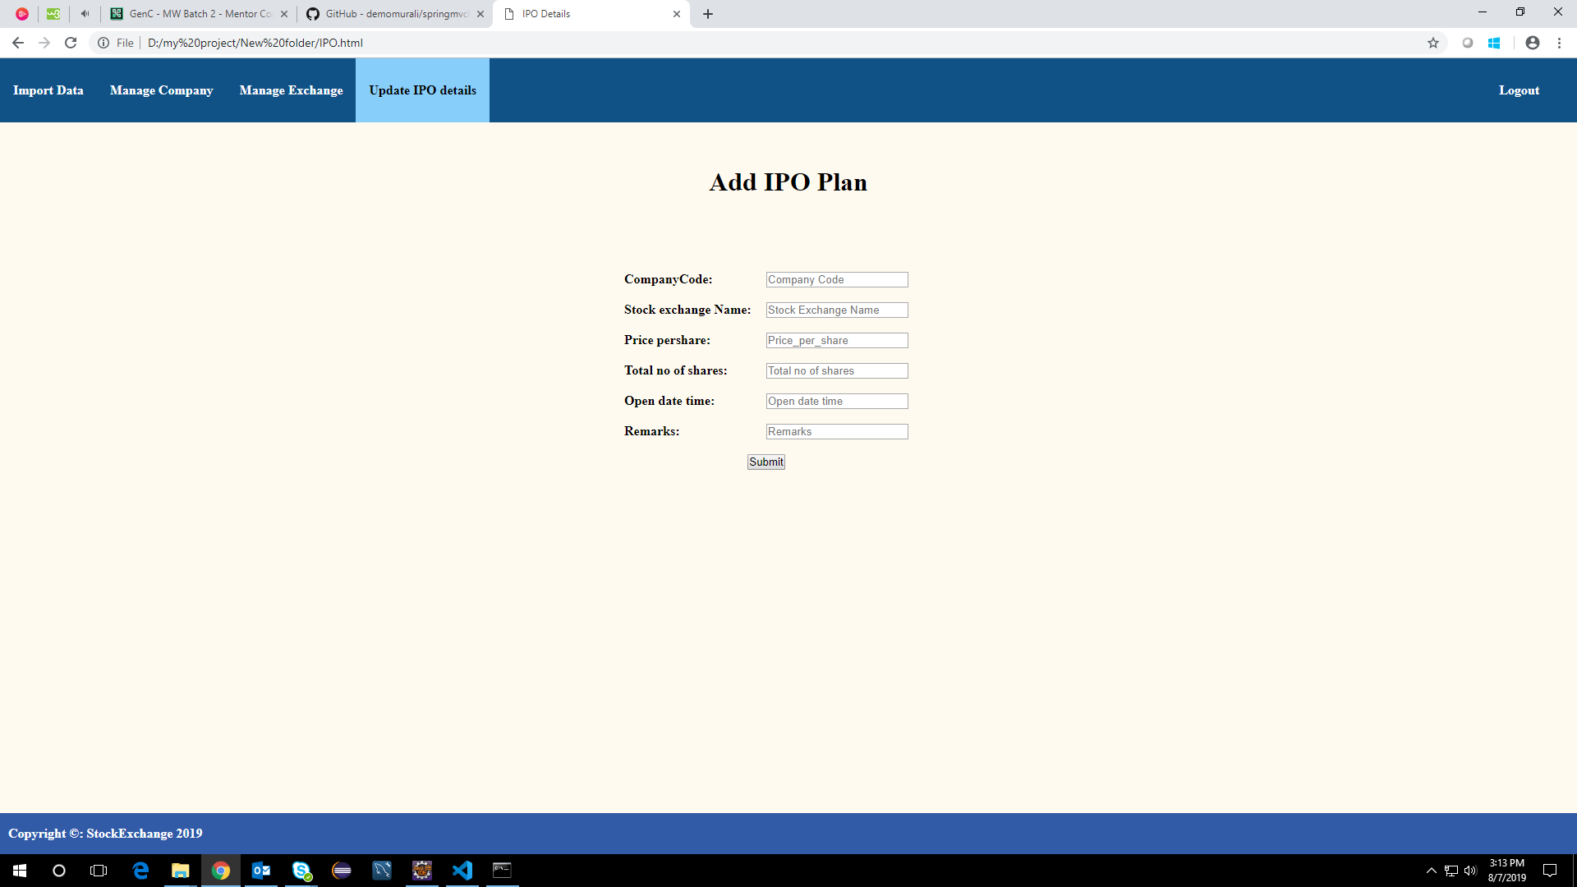

**SCHEMA DIAGRAM**

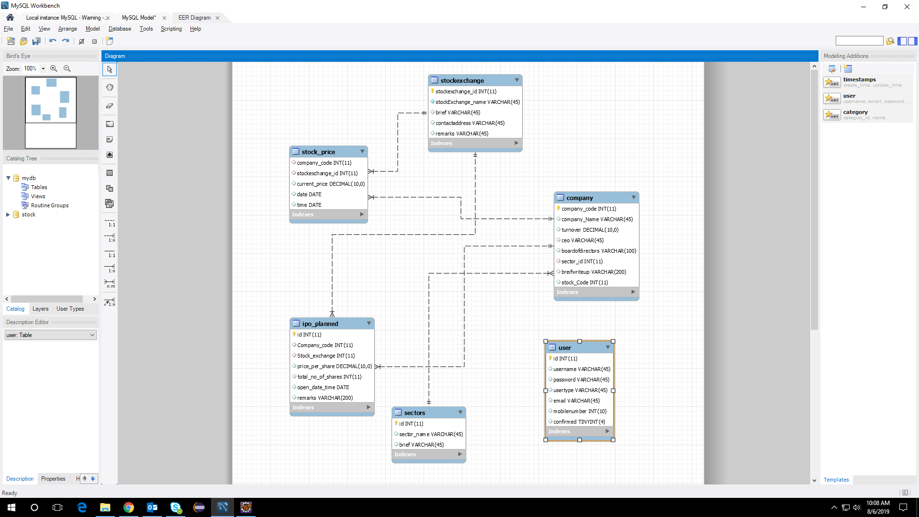

**CODE GITHUB LINK :**

https://github.com/NAVEDHA98/StockMarketChart